GOVERNMENT OF NCT OF DELHI
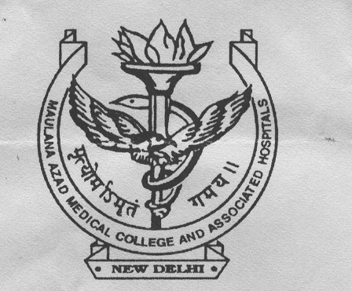
MAULANA AZAD MEDICAL COLLEGE
And Associate Lok Nayak, Govind Ballabh Pant Hospital &
Guru Nanak Eye Centre, 2, B.S.Z. Marg,
New Delhi-110 002
(IEC, MAMC)

The result of the recruitment (on contractual basis) of the staff of IEC, MAMC as per the interview held on 20.08.2024 is as follows:-

- Ethics Committee Co-ordinator
Selected Candidate:- 1. Taposh Sarkar
Wait-list Candidates 1. Vinay Kumar, 2. Renu Kanwar

- Data Entry Operator Cum Office Assistant
Selected Candidate:- 1. Raj Kishore
Wait-list Candidates 1. Deepak Sehgal

- Office Assistant
Selected Candidate:- 1. Paras Malik
Wait-list Candidates 1. Rakesh 2. Kapil Dutt

The selected candidates may collect their offer letter from the office on 27th August,2024

